Lesson 11: What can we design to better protect objects in a collision?

Previous Lesson | We revisited our collision types from Lesson 1 and explained why some objects were damaged and others weren’t in different collisions. We used these ideas to answer questions on the Driving Question Board and took an assessment to apply our new ideas to a new set of collision-related phenomena in the context of baseball.
This Lesson  Anchoring Phenomenon  2 days   | 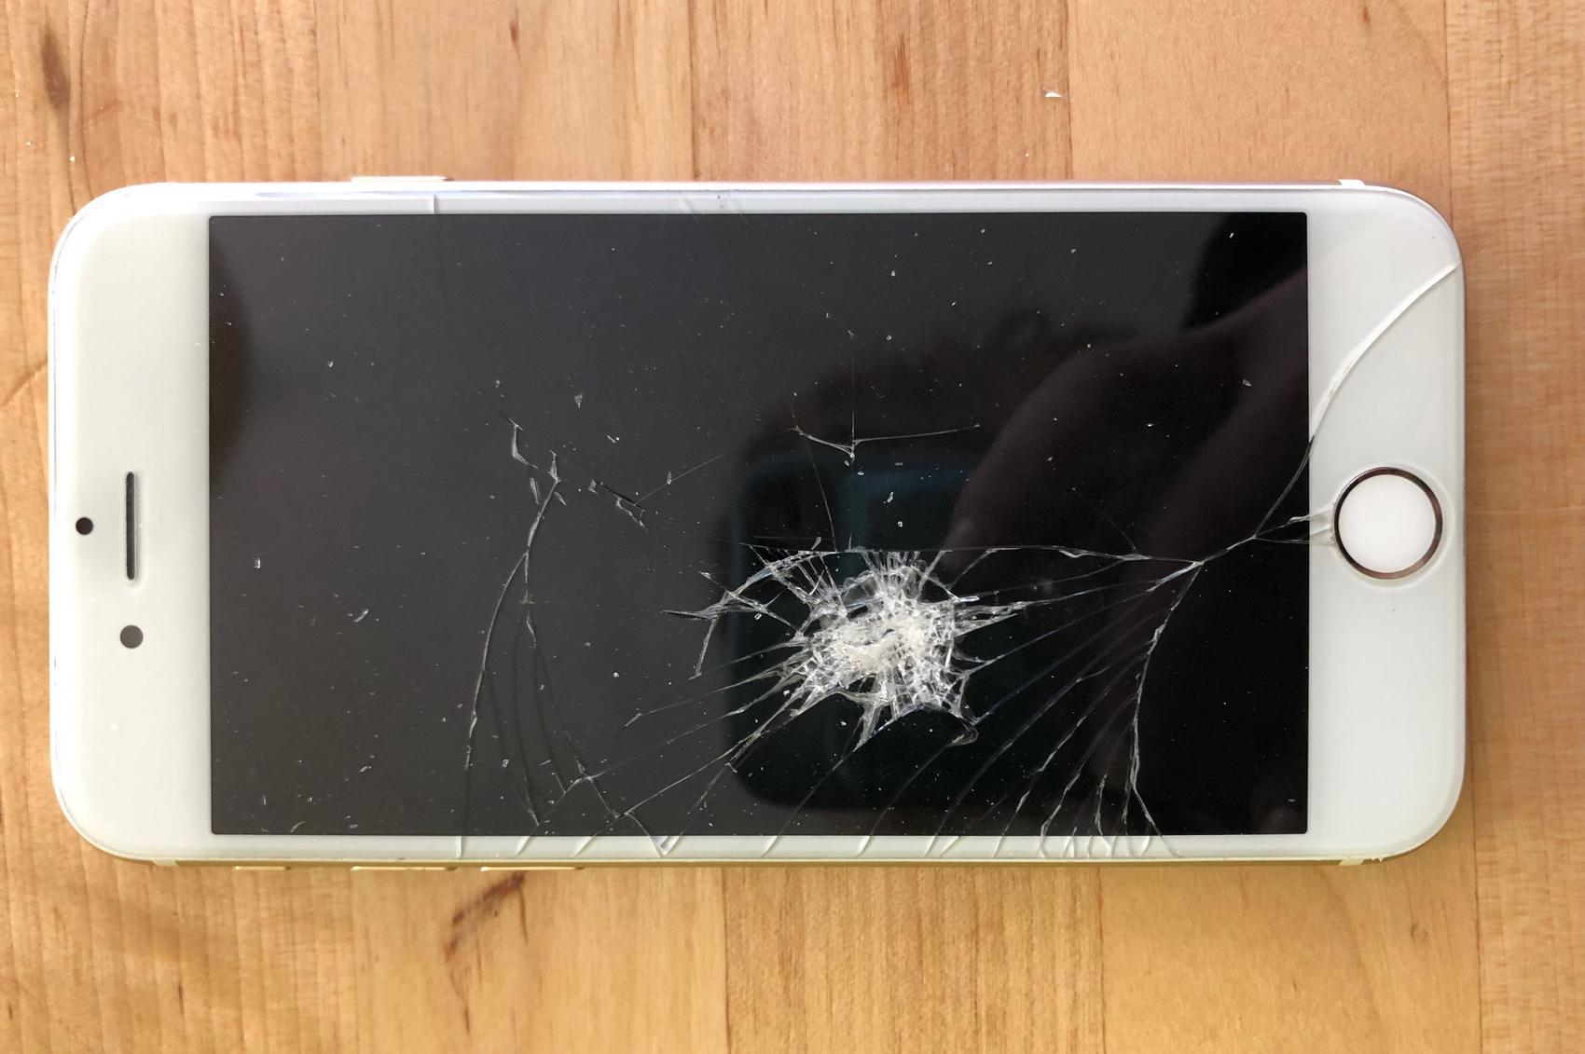 | We look back at our anchor and discover that some phones were in protective cases when they were damaged. We develop new phone case criteria and constraints and design our own protection device for something we want to protect. We receive feedback on our designs and consider what criteria and constraints all designs need to protect objects. We develop questions about our designs and ideas for investigation. We determine that we need to figure out the best damage-reducing materials.
Next Lesson | We will conduct an investigation to determine what materials reduce peak force in a collision and compare the structure of the materials. We will determine whether peak force is reduced equally on both objects, regardless of size, and try to develop a model to explain how the materials function to help reduce peak forces.

BUILDING TOWARD NGSS  MS-PS2-1, MS-PS2-2, MS-PS3-1, MS-ETS1-2, MS-ETS1-3, MS-LS1-8   | What students will do  11.A Define a problem that can be solved with the development of a protective device to reduce damage (peak force) during a collision by identifying and considering multiple criteria and constraints along with specific materials, shapes, and designs of devices that reflect our science ideas of how certain material properties function in a collision.  11.B Design a solution to a problem to reduce the damage to an object in a collision (by reducing peak forces) by considering the properties of different, individual materials and shapes being used to serve particular functions.  What students will figure out  - All protection devices have similar criteria and constraints.  - Device shape, material, and structure have something to do with protective devices reducing damage to an object.  - We need to determine what makes certain materials better at reducing damage than other materials.

Lesson 11 • Learning Plan Snapshot
Part | Duration |  | Summary | Slide | Materials
1 | 10 min |  | REVISIT ANCHORING PHENOMENON  Look back at phone case data from the anchoring phenomenon. Consider how to better protect phones from damage. | A-B | Building a Better Phone Case chart, markers
2 | 6 min |  | CHART OTHER OBJECTS THAT NEED (BETTER) PROTECTION  Record what objects students believe need better protection during a collision and what changes can make that object more protected. | C-D | Objects that need (better) protection during a collision chart, markers
3 | 8 min |  | DETERMINE CRITERIA AND CONSTRAINTS OF INDIVIDUAL DESIGNS  Select a personal object to protect and develop criteria and constraints for that object. | E-F | Protection Device Design Thinking, Objects that need (better) protection during a collision chart, Building A Better Phone Case chart
4 | 10 min |  | DRAFT DESIGN IDEAS  Use Drafting Our Protection Device Design to draft the initial protective device designs. | G | Protection Device Design Thinking, Drafting Our Protection Device Design
5 | 11 min |  | RECEIVE FEEDBACK ON DESIGNS  Introduce a structured feedback process to gain feedback on initial designs. | H-I | Drafting Our Protection Device Design, 1 timer

End of day 1
6 | 13 min |  | HOME LEARNING FEEDBACK GALLERY WALK  Look back at home learning to see what others would like to protect. | J-K | At least 3 3”x3” sticky notes for gallery walk feedback, Drafting Our Protection Device Design
7 | 8 min |  | DEVELOP A SHARED CRITERIA AND CONSTRAINTS LIST  Work together to identify criteria and constraints that all designs should be structured around. | L-M | Drafting Our Protection Device Design, partner feedback sticky notes, Building a Better Phone Case chart, Whole-class Criteria and Constraints chart, markers
8 | 20 min |  | DEVELOP QUESTIONS AND IDEAS FOR INVESTIGATIONS  Look back at the classroom artifacts and student artifacts to brainstorm questions and ideas for investigation related to structure, function, design, and materials. | N-O | 3 more 3”x3” sticky notes, Protection Device Design Thinking, Drafting Our Protection Device Design, partner feedback sticky notes, Objects that need (better) protection during a collision chart, Building a Better Phone Case chart, Whole-class Criteria and Constraints chart, chart paper, markers
9 | 4 min |  | NAVIGATION  Determine next steps to investigate what materials would make better protection devices. | P

End of day 2

Lesson 11 • Materials List
 | per student | per group | per class
Lesson materials | - Protection Device Design Thinking  - Drafting Our Protection Device Design  - At least 3 3”x3” sticky notes for gallery walk feedback  - partner feedback sticky notes  - 3 more 3”x3” sticky notes |  | - Building a Better Phone Case chart  - markers  - Objects that need (better) protection during a collision chart  - Building A Better Phone Case chart  - 1 timer  - Whole-class Criteria and Constraints chart  - chart paper

Materials preparation (15 minutes)

Review teacher guide, slides, and teacher references or keys (if applicable).

Make copies of handouts and ensure sufficient copies of student references, readings, and procedures are available.

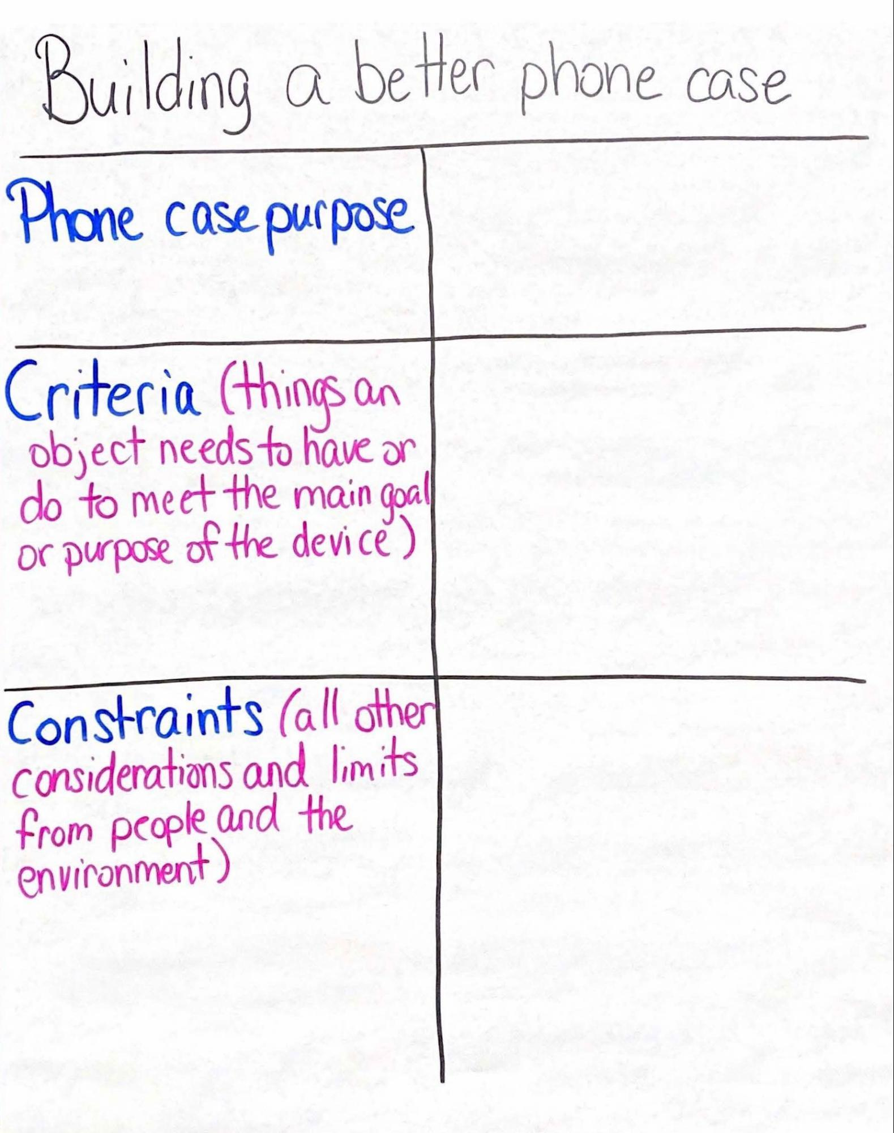
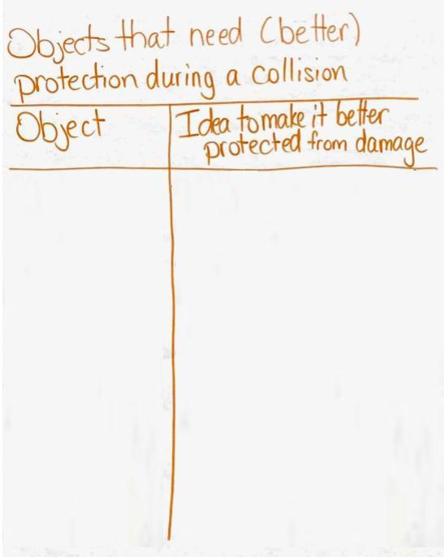
Create a chart titled “Building a Better Phone Case”
- Section off the chart into 3 rows with these labels at the left of the rows:
- Phone case purpose
- Criteria (the things an object needs to have or do to meet the main goal or purpose of the device)
- Constraints (all other considerations and limits from people and the environment)

Create a chart titled “Objects Others Would Like to Protect from Damage”.

Create a T-chart titled “Whole-class Criteria and Constraints” and with these column headings:
- “Criteria” on the left
- “Constraints” on the right
Create a T-chart titled “Objects that need (better) protection from a collision” and with these column headings:
- ”Object” on the left
- “Idea to make it better protected from damage” on the right

Lesson 11 • Where We Are Going and NOT Going

Where We Are Going

In this lesson, students are tasked with drafting a design of a device to reduce damage for an object of their choice. Students will be asked to take into consideration why they are using certain materials and how those materials might reduce damage in a collision. Students will represent changes they believe are occurring to the protection device’s materials in a collision that will reduce the peak force on the object it is protecting. Students will also develop questions that they need to figure out regarding materials and device design (shapes and so forth) to best meet the criteria and constraints of the design.

Students are reminded in this lesson that in the Homemade Heater Unit, Cup Design Unit, and Tsunami Unit, they worked with criteria and constraints They recall examples of how they used these in the past to design and evaluate solutions for different stakeholders (entities like people, groups, or things that are impacted by design decisions).

Where We Are NOT Going

This lesson will not develop an explanation of why some materials are able to reduce peak forces on the objects they are protecting in a collision. At this point, the initial explanations are used to generate interest and competing ideas that will lead to the need in Lessons 11-14 for further investigation into how shape and material type influence the behavior of cushioning materials and how this affects peak force produced in a collision.

LEARNING PLAN for LESSON 11
1 · REVISIT ANCHORING PHENOMENON | 10 min
MATERIALS: Building a Better Phone Case chart, markers
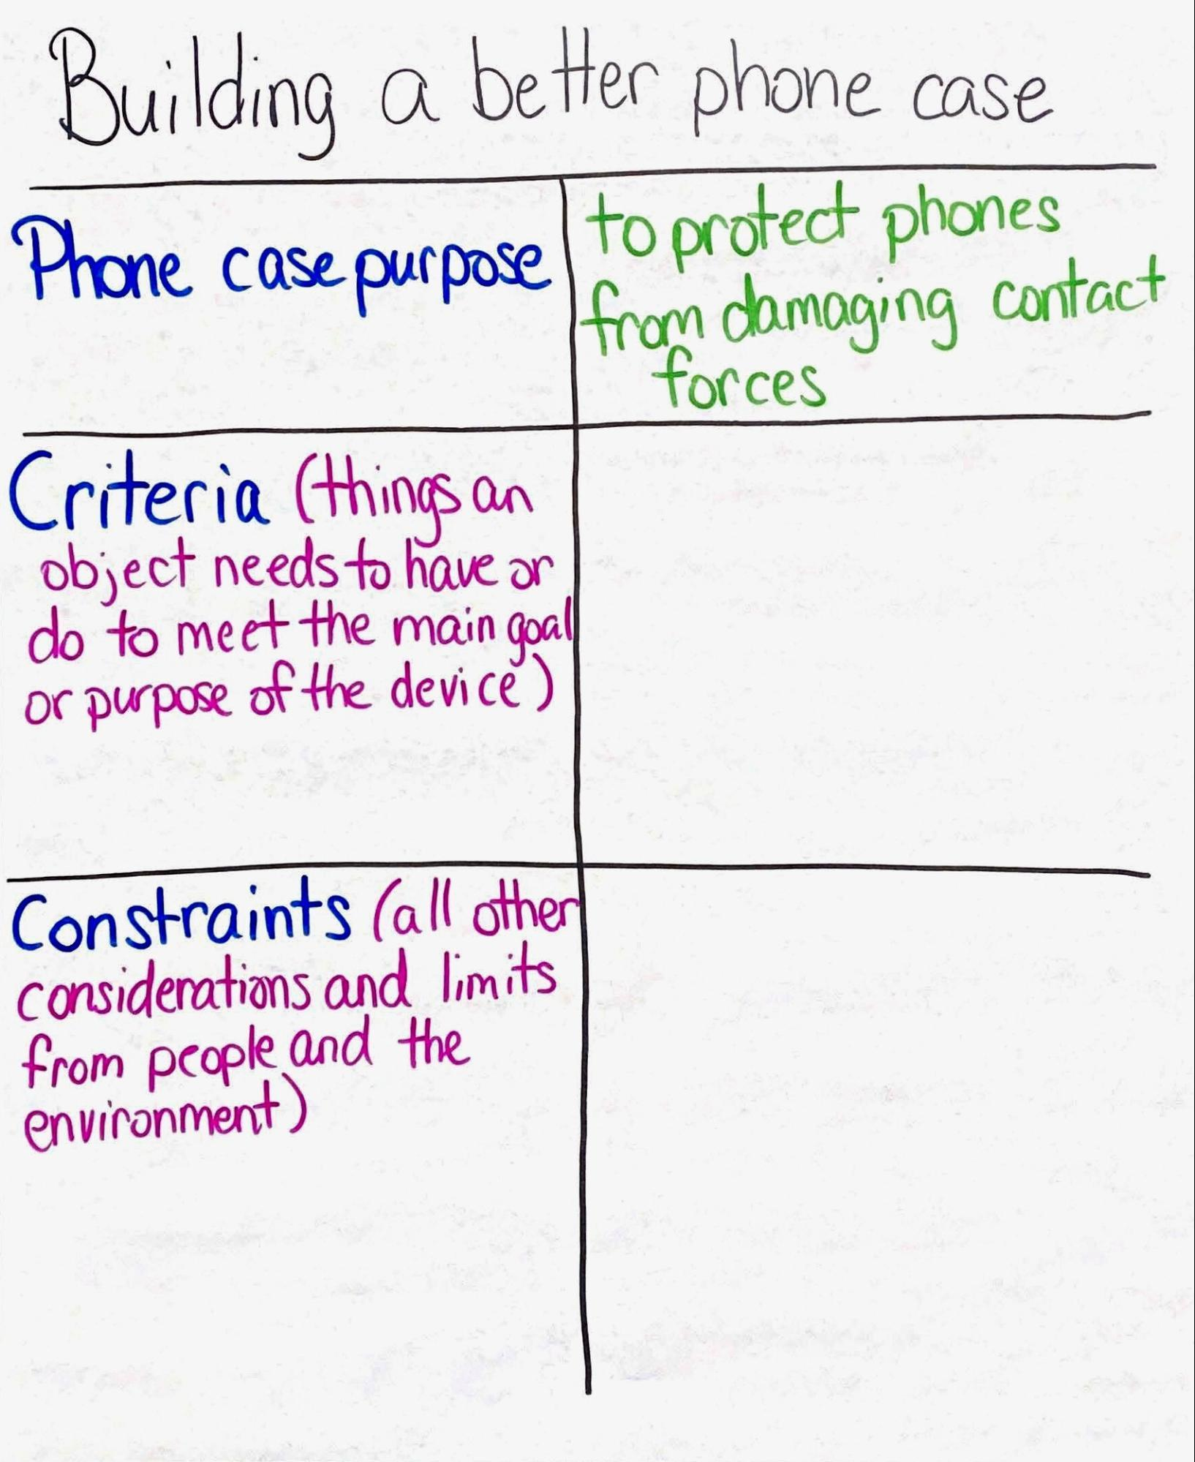  Recall anchoring phenomenon. Project slide A. Say, When we started this unit, we looked at some interesting data. I was looking at it again and one piece of data stuck out. We’ve learned about and explained how different objects can get damaged in a collision, but even when some objects are protected sometimes they still get damaged. Look at these data from our original phenomenon.  Read the data from slide A. Point out the datum regarding phones breaking while still in their cases.  - 27% of people said that their phone was in a case when they broke it.  Say, Even with cases, 27% of the phones were still getting broken! So the cases do not completely prevent damage.  Establish the purpose of a phone case. Display the Building a Better Phone Case chart. Say, If damage can still occur when a phone is in a case, why do people even use them? What would you think people would say is the primary purpose of a phone case?  Students should respond that a phone case is meant to protect phones from damaging contact forces in many situations. Record this idea on the Building a Better Phone Case chart in the column to the right of “Phone Case Purpose”. Say, It seems like the phone cases, while helpful, are not fully protecting phones from damaging contact forces in every collision. What design features do we think would be needed to refine a phone case to better serve its purpose of protecting phones?  Brainstorm phone case ideas. Ask students what potential design features a phone case needs that might offer better protection. Example responses are below.  Shift focus to criteria and constraints. Transition to the ”Criteria” and ”Constraints” sections of the chart.  Project slide B. Say, We have some ideas about what a phone case would need to better protect our phones. Let’s create a list of the criteria and constraints a phone case designer would need to consider in making a better phone case.  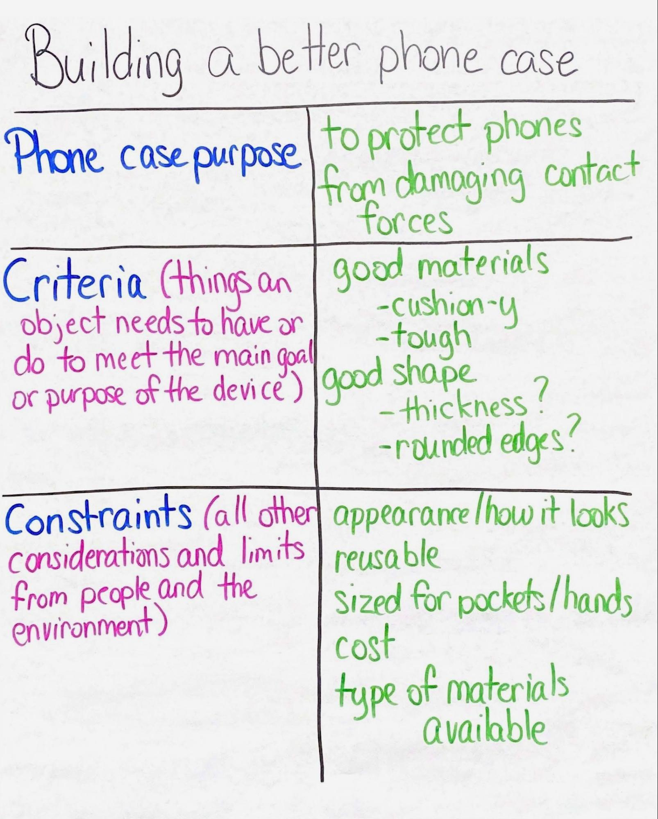  Remind students that in the Homemade Heater Unit, Cup Design Unit, and Tsunami Unit, we worked with criteria and constraints. In the Cup Design Unit students used criteria and constraints to design a new cup to keep a drink cool. In the Tsunami Unit students used criteria and constraints when evaluating different designs to protect communities from a tsunami. In the Homemade Heater Unit students used criteria and constraints to create a homemade heater for an MRE.  Criteria are the things a device needs to have or do to meet its main goal or purpose. Constraints are all other considerations and limits from people or the environment. Place the words criteria and constraints on the Word Wall for student reference. Remind students that we also worked together to define stakeholders in the Homemade Heater Unit and Tsunami Unit. Stakeholders are the entities like people, groups, or things that are impacted by design decisions. Add stakeholders to the Word Wall.✱  Ask students the questions from slide B and have 2-3 students share out their ideas. Below are suggested prompts and sample student responses to the slide B questions. Fill in the rest of the Building a Better Phone Case chart as students share their criteria and constraint ideas.  Say, It seems like we have identified some of the criteria and constraints a designer of a phone case should consider. But we all know phones aren’t the only objects that people might want to protect from damage. Let’s brainstorm some other possibilities. Is there anything other than a phone that you would like to better protect? | ✱ ATTENDING TO EQUITY  Supporting Emerging Multilingual Learners: When revisiting vocabulary from past units, strategies that may benefit emerging multilingual learners are to use student-friendly definitions, make connections to cognate words when possible, and include a visual representation of the word. Adding the word to the Word Wall allows students to have a reference point for the meaning of the word, and by relating it to past experiences students can make connections across units to help develop the full meaning of the word, not just what the word means in one contextualized area or unit. Because these words were previously earned, meaning can be expanded upon as students engage in the engineering design process in a new context.
  Suggested prompts | Sample student responses | Follow-up questions
  Think about your phone cases. What could make that case better at meeting its purpose of protecting your phone? | Maybe if there was something on the front to protect the screen.  If there’s something there it might not hit it directly. | Why might that be helpful? What would that do to help protect the phone during a collision?  So you’re saying that maybe if we reduce the amount of direct contact with the phone, that may help make the case better?
  What other things could make the case a better case? | There could be, like, rounded bumpers on the corners. Last time I broke my case it landed on the corner.  Maybe more material helps protect it better. | Why might adding material or changing the shape be beneficial for phone protection?  So you’re saying increasing the thickness or changing the shape of materials seems to help reduce damage in a collision?
  Any other ideas that might make the case a better case? | I think changing the type of materials, not just adding more, may make it a better case.  Some fragile things come in bubble wrap. Maybe we could use something like bubble wrap to protect the phones. | What changes to the materials are you thinking?  So you’re saying that the type of material used may help reduce damage in a collision?
  Suggested prompts | Sample student responses | Follow-up questions
  Let’s look at row 2 on our chart. What criteria would a phone case need to have to better meet the purpose of protecting the phone? | We need to use good, cushiony or tough materials that protect phones when they are hit. | So maybe we need to consider what materials work best for protecting a phone from contact forces?
  We might need it to have rounded edges or thick sides, like thick and padded to protect the phone. The shape probably matters. | So we want our device to have a good shape to help meet the goal of protection of our phones?
  Awesome. Let’s think about the constraints. What are some stakeholder considerations we should have? Is there anything that would limit our designs? | We would have to consider how it looks. We would want people to want to buy it. | So one constraint would be the appearance of the device?
  It would have to work a lot of times, not just for one drop or impact. | So you’re saying that it needs to be reusable or sturdy?
  We can’t let it get too big. We need it to be comfortable to hold. | We think one limit to the design might be size.
  Money would definitely limit our designs. We don’t have unlimited money. | That’s true. We would have to consider what people would spend on this. Cost will need to be on our constraints list.
  We can’t use just any material we want; we might not have access to some materials we may want to use. | So we have to be realistic about the type of materials we have. We would have to use easy-to-find materials.

2 · CHART OTHER OBJECTS THAT NEED (BETTER) PROTECTION | 6 min
MATERIALS: Objects that need (better) protection during a collision chart, markers
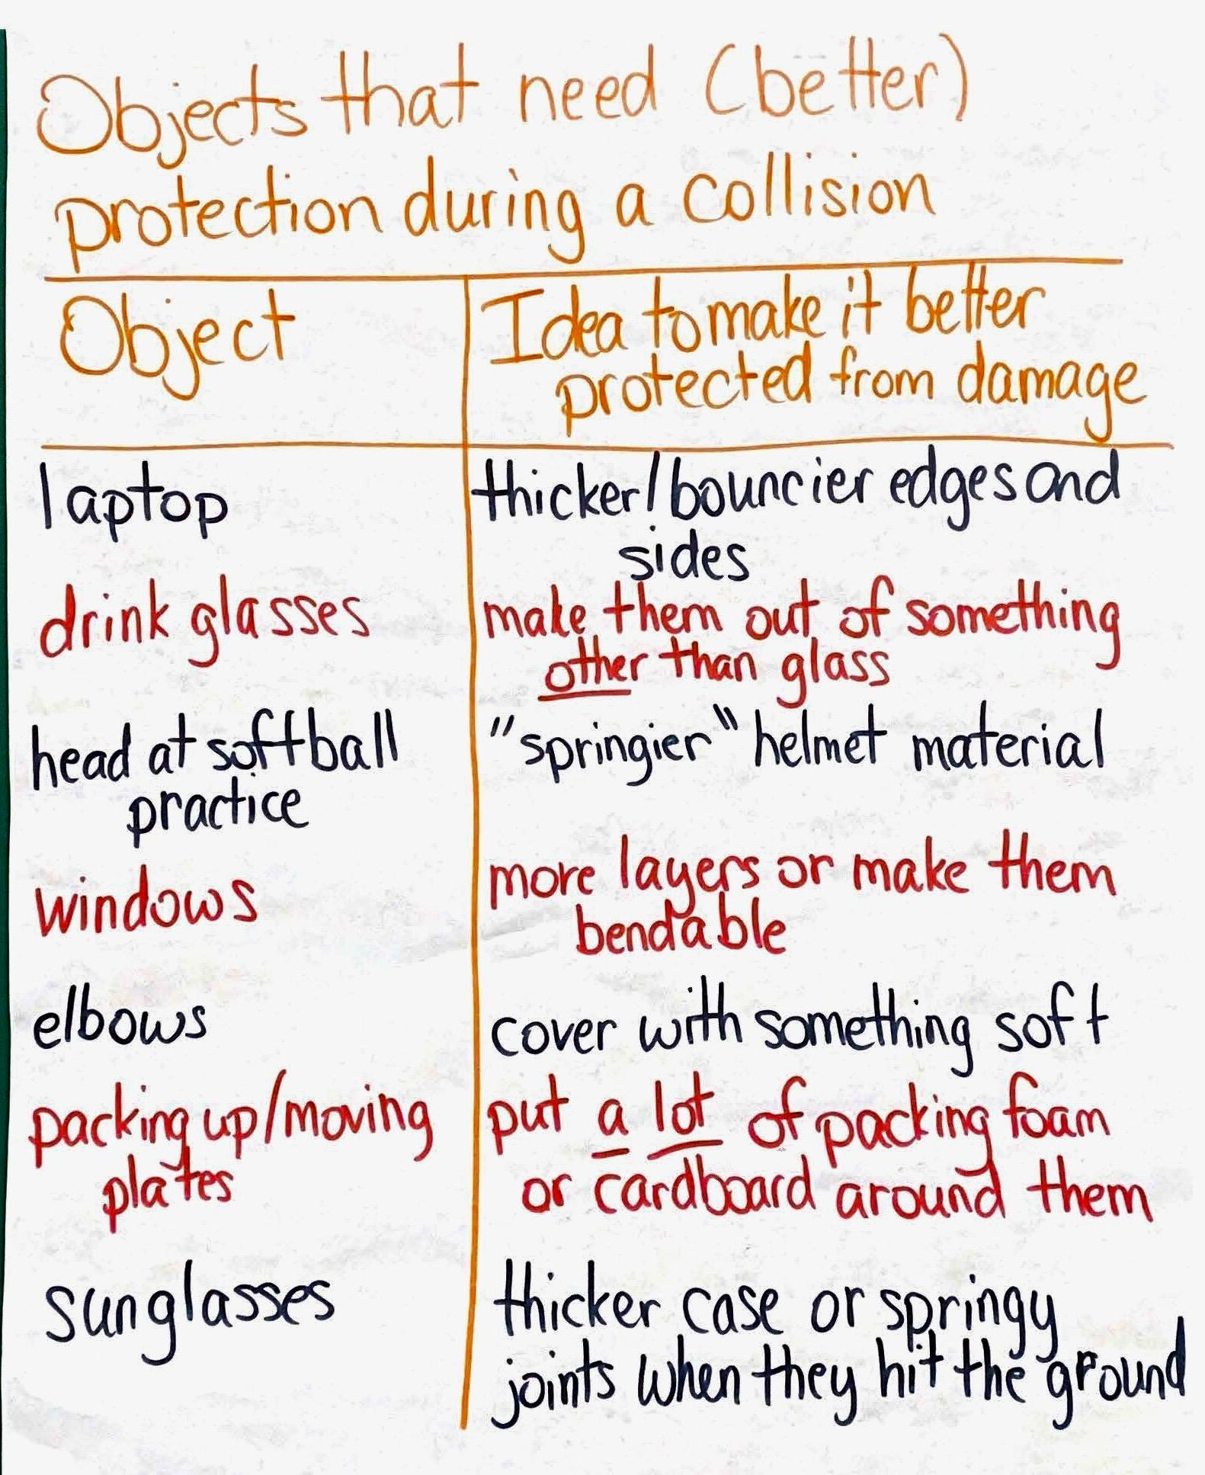
Project slide C. Explain that the word better is in parentheses because some objects don’t have protective devices. Other objects may already have protection devices, but they may need to be improved. Instruct students to turn and talk about the following questions.
- What are some objects that need (better) protection in a collision?
- What general ideas do you have to make it (better) protected from damage?

Make a record of better-protection design ideas. Project slide D. After about 4 minutes of student turn and talk, bring the class together to share their ideas. Ask students what objects they would want to protect or they think could be better protected. Display the Objects that need (better) protection during a collision chart. Create a record of the objects that need (better) protection in the left column of the chart. As students share, list in the right column one thing that would make the object more protected. If students suggest something that already has a protective device (such as a head in a helmet during a sporting event), ask them what would make the object better protected or make the existing protection device better.

3 · DETERMINE CRITERIA AND CONSTRAINTS OF INDIVIDUAL DESIGNS | 8 min
MATERIALS: Protection Device Design Thinking, Objects that need (better) protection during a collision chart, Building A Better Phone Case chart
Say, We have a lot of objects that seem to need better protection, and we have a lot of ideas on how to make better protection devices.  Turn and talk about potential protection devices. Project slide E. Reference the Objects that need (better) Protection during a collision chart and point out the number of items that the class believes need (better) protection.  Direct students to turn and talk with their partner about the following prompts on slide E:  - If you had to pick only one object that you interact with a lot that you would want to protect from damage, what would you pick, and why?  - If we were to make a protection device for this object, what damage-reducing solutions could you come up with?  Pause students after roughly 2 minutes of partner sharing. Ask 2-3 students to share what object they would choose to protect and what solutions they would come up with.  Select an object to protect. Project slide F. Distribute Protection Device Design Thinking. Say, It sounds like you all have great ideas. Let’s see if we can draft some of these ideas on paper and think about how we can better protect our objects.  Instruct students to write their name on the handout. Look at the first line with the students. Ask students to pick one object from the Objects that need (better) protection during a collision chart or choose an object that they would personally like to protect. Have students write this object down on the first line.  Look at the next part with students: “Define the purpose”. Ask students to consider what the overall purpose of a protective device would be for an object. Give students time to write down the purpose of this protective device.✱  Develop criteria and constraints for students’ chosen object. Say, As we work through developing a device that can better protect our objects, we have to think about what would make this protection device function better than any existing designs. We have to think about what we would need to do to meet the overall purpose of the design and any limits or additional considerations that stakeholders may want or need. Let’s use the next three sections to help us determine our criteria and constraints.  Make connections to the Building A Better Phone Case chart. Read over the last three sections with students. Point out that this is comparable to the ideas that we developed on our Building a Better Phone Case chart. Point out for students the ”Criteria” and ”Constraints” rows on the chart. Some students may point out that the overall goals or criteria are similar, if not the same, to the protection device they are wanting to design. If students make this observation, use this observation to navigate to the next section. If students do not make this observation, ask students if there are any similarities between the two lists and allow students to give 2-3 goals or criteria that are similar or the same.  Compare the chart with student handout answers. As students are thinking about their object that they would like to protect, have them compare their protection device with the Building a Better Phone Case chart.  Ask students these questions:  - Are there any criteria that would apply to your individual design AND to a better phone case?  - Are there any constraints that also apply to both devices?  Have students consider the criteria and constraints that they will have to keep in mind while they are drafting their designs. Have students record these ideas in the last three sections on their handouts.  Ask 2-3 students to share what object they would like to better protect and what their criteria and constraints would be. Allow students to add to their lists as their classmates share their ideas for criteria and constraints. | ✱ SUPPORTING STUDENTS IN ENGAGING IN ASKING QUESTIONS AND DEFINING PROBLEMS  Defining the design problem and identifying the goal or purpose of the design is central to the design work. The clearly defined design problem will help students better articulate the criteria and constraints needed to optimize the design and assess the effectiveness of any modifications to the device during the design process. The identification of goals also helps guide modifications to devices to better meet the stakeholder needs and design considerations.
  ASSESSMENT OPPORTUNITY | Building towards: 11.A Define a problem that can be solved with the development of a protective device to reduce damage (peak force) during a collision by identifying and considering multiple criteria and constraints along with specific materials, shapes, and designs of devices that reflect our science ideas of how certain material properties function in a collision.  What to look for/listen for: On Protection Device Design Thinking students define the problem at the top of the page. Look for students to identify that the purpose of the device is for protecting the object from damage in a collision. Look for relevant criteria and constraints as students engage in the handout and listen for justification of the type of material and the shape of the materials they propose to use in their designs.  What to do: If students are struggling with identifying the purpose of the device, refer them to the Building a Better Phone Case chart. Ask students why they put a case on their phone and what that case is meant to do. While identifying criteria and constraints, have students think about the common example of the phone case once again. Criteria are directly related to the purpose. Ask students questions like these:  - What does this design need to have to serve the purpose of protection?  - What qualities would those designs have?  - What does the design need to do to serve its primary purpose?  For constraints, ask students to look back at the common example again for ideas. Ask questions like these:  - What are some things people would want out of this device that might affect how it functions?  - What else do we need to think about that the stakeholders want or need?  - Are there any restrictions due to the location where the object or design would be used?  - Are there any restrictions because of the way the object or design will be used?  As students consider different materials, refer them back to their previous work in Lessons 5-9 to help explain how objects behave in a collision.

4 · DRAFT DESIGN IDEAS | 10 min
MATERIALS: Protection Device Design Thinking, Drafting Our Protection Device Design
Give students time to draft their initial designs. Project slide G. Pass out Drafting Our Protection Device Design to students. Point out that column 1 is for an overview of their design. Students should draw what their design would look like, what materials they would use, and what shapes would be used in various locations such as corners and sides. Encourage students to use their design thinking from Protection Device Design Thinking to help them design a protective device. Point out that column 2 is space for a zoomed-in view of the main building materials in their device and that students should show what they picture the material(s) that make up their device doing a split second after something collided with it. Challenge students to really try to explain what the device is doing during the collision that enables it to reduce the peak forces on the object it is protecting in a collision.  Give students time to draft their ideas.✱  Circulate to clarify student thinking. As students are drafting ideas, circulate and ask students the following questions to clarify their thinking and refine their decisions.  - What shape are you using for your structure?  - What is special about that shape compared to other shapes?  - Would another shape work better or worse to help protect your object from damage? Why (or how)?  - What constraints did you identify? Do you think your device would meet those constraints? Do you have to consider sizing or type of material?  - What criteria did you identify? Can you explain on your handout how your device is able to meet that criteria?  - How does your main shape and materials help meet your criteria?  - What is special about that material that helps protect against damage?  - How does that material react in a collision?  - What other materials would function like that material? What made you choose this specific one?  - How did you use those other ideas in your device design?  - Can you show and explain what sets your device apart from the other devices? | ✱ SUPPORTING STUDENTS IN DEVELOPING AND USING STRUCTURE AND FUNCTION  Drafting Our Protection Device Design provides an opportunity to engage in both main elements of structure and function. Column 1 reflects student understanding of how particular structures can be utilized to serve certain purposes or functions based upon the science ideas learned thus far in the unit. Column 2 allows students to start thinking about how the structures (shape, material, and properties of these materials for the designed device) are affected and change over time as well as at a microscopic level during the collision. Students are likely to show the protection device deforming, based on the previous work in the unit, but may be less likely to show it transferring force to the object they are protecting in the collision.
  ASSESSMENT OPPORTUNITY | Building towards: 11.B Design a solution to a problem to reduce the damage to an object in a collision (by reducing peak forces) by considering the properties of different, individual materials and shapes being used to serve particular functions.  What to look for/listen for: Treat this as a pre-assessment of students’ understanding of new ideas that they will develop in the last lesson set of the unit. The first idea is related to the microscopic structure of cushioning materials. Many effective cushioning materials provide pockets or gaps of space or air between the layers of materials for the cushioner to “give”. Look for this in the second column of the design drawing. The second idea is related to how cushioners reduce peak forces in a collision. Look for students showing the protection device deforming, based on the previous work in the unit. Students will likely not show the ideas listed below, as they are ones that are new to the remainder of the unit:  - The amount of peak force is reduced because the cushioner applies a weaker force over a larger distance in a collision, which has as much effect on reducing the kinetic energy of an object as a stronger force over a shorter distance.  - These forces are transferred to both objects that the cushioner is in contact with (including the object it is protecting).  - The shape of a cushioner can be designed to distribute that force over a greater surface area, thereby reducing the amount of peak force occurring at a single location on the object being protected.  What to do: Drafting Our Protection Device Design will reveal any preconceptions about how students believe forces on the protected object can be reduced by layering certain materials. Since these ideas will be introduced in the remainder of the unit there is no need for remediation at this point. Make a copy of these explanatory models at the end of day 2 and compare them with what students show in their individual model and explanation at the end of Lesson Set 3. You may also want to have students analyze their growth by comparing these artifacts related to the ideas listed above.

5 · RECEIVE FEEDBACK ON DESIGNS | 11 min
MATERIALS: Drafting Our Protection Device Design, 1 timer
Introduce a design feedback task and provide feedback. Project slide H. Explain that in order to make a better protection device, it can’t be just what the designer of the device wants. It should meet the needs of many people who might want to use and buy it. Because of that, it is important to get feedback from others. Tell students that you will set a timer for 4 minutes. One student will explain their design to a partner, then their partner will have until the end of the 4 minutes to give feedback. When the 4-minute period has ended, the partners will shift roles. In the second 4-minute period the second person will explain their design and their partner will give feedback.  Instruct students to look at the questions on the slide. Read the feedback questions with students. Tell students to answer these questions as they give feedback to their partners.  - What do you like about the design?  - What changes would make it “better” at protecting the object?  - What other changes would you make for the device to be more appealing to stakeholders?  Allow students a total of 8 minutes to give and receive feedback with their partners, reminding students to shift roles after the first 4-minute timer goes off.    Introduce home learning feedback task. Project slide I. Say, We have received a lot of feedback on our designs! Tonight for home learning, see what your family and others think of your design. Take home your design tonight and revise it based on the feedback they give you.  Have students ask others to give them feedback on their designs and list any other considerations family or others might want students to consider. Encourage students to write any feedback and considerations down in the margins or on the back of Drafting Our Protection Device Design. Tell them to be ready to share their feedback and ideas in the next class meeting and that they will be doing a gallery walk with their designs.✱ | ✱ ATTENDING TO EQUITY  Universal Design for Learning: Engineering design tasks are established with the purpose of meeting the goals of the design. The overall design of how the device meets those goals is directly impacted by the needs and considerations of the community (stakeholders). Taking home the student-created designs for additional feedback allows students to get more-relevant stakeholder input and engage with others in their community to understand how designs affect and are shaped by people involved. Additional stakeholder feedback will also contribute to the relevance and authenticity of the task to design a protective device for the object of the student’s choice.
  ADDITIONAL GUIDANCE | Questions are given for student feedback to help students focus on the protective qualities of the design while also allowing students to serve as the potential voice of a stakeholder. Structuring student feedback around focused questions helps students keep the feedback meaningful and connected to the overall science ideas of designing with stakeholders in mind and developing a device that has the primary purpose of protection.

End of day 1

6 · HOME LEARNING FEEDBACK GALLERY WALK | 13 min
MATERIALS: At least 3 3”x3” sticky notes for gallery walk feedback, Drafting Our Protection Device Design
Share home learning feedback. Project slide J. Have students get out their design ideas from the last class. Ask students to think about their home learning. Have students turn to a partner and share the feedback they received. If students did not receive feedback on their designs, have them consider their partner’s feedback for their design and make any modifications they think are needed.

Bring students back together and ask students to place a checkmark or a star next to any changes they have made due to feedback from others.

Say, How many of you feel that feedback from others helped make your initial design for a protective device better? Raise your hand if you received helpful feedback from someone else for your design.

As several students raise their hand, say, Great! It looks like we have gained some good ideas and feedback from others for our personal protective devices. It seems like the more specific the feedback, the better our modifications are. Let’s take some time today and really focus on our feedback to make sure our designs are meeting the goals we identified.

Introduce gallery walk questions. Project slide K. Tell students that in a moment we will have a gallery walk to give feedback on each other’s designs. Explain that good feedback is specific and actionable, meaning that the feedback can be used to make something better, so they will be giving feedback over 3 important design questions. Go over feedback prompts with students.
- What changes would make it “better” at protecting the object?
- What other changes would you make about the way it looks, the material, or the shape that would make you (or others) more likely to want to use it more?
- What parts do you think will function well?

Present feedback structure. Tell students that they should give feedback on 3 different designs and use all 3 prompts during their feedback time. Students can give more than 3 pieces of feedback if they wish, but they should provide feedback on 3 different designs before coming back around to give more feedback. If they come to a design that has 3 sticky notes on it, they should try to find another design that has fewer than 3 sticky notes and leave feedback. No person can give more than one sticky note to a single design.

Provide time for a gallery walk. Arrange the design drafts for easy student access and viewing. Pass out at least 3 sticky notes to each student. Provide 6 minutes for students to give feedback on designs. At the end of the 6 minutes, have students return to their seats with their designs and read over their feedback.

7 · DEVELOP A SHARED CRITERIA AND CONSTRAINTS LIST | 8 min
MATERIALS: Drafting Our Protection Device Design, partner feedback sticky notes, Building a Better Phone Case chart, Whole-class Criteria and Constraints chart, markers
Compare feedback. Project slide L. Instruct students to work with a partner to identify commonalities in their feedback. Students will use the following prompts to guide their conversations.
- What do your feedback and designs seem to have in common?
- Do your designs have similar criteria and constraints? If so, what are they?
- Do you have any feedback that is not similar to your partner’s feedback?

Lead a criteria and constraints whole-class discussion. Project slide M. Bring students together and have them consider the criteria and constraints. Say, Do we have a shared goal for all of our devices? Students will identify that we all have the same shared goal of object protection.

Say, Interesting. I wonder if we were to look at our criteria and constraints if they would also be similar across all protection devices. Let’s see if we all seem to have common needs, limits, and considerations.

Have students turn and talk about the following question:
- If we were to make a criteria and constraints list that would work for all our designs, what would be on the list?

Record class criteria and constraints. Display the Whole-class Criteria and Constraints T-chart. Use the same prompt from above to engage in a discussion about criteria and constraints that would be shared across designs. Start by pointing to the ”Criteria” side first and asking students if they have a criterion that everyone might have on their designs. Students can reference Protection Device Design Thinking or Drafting Our Protection Device Design to look for criteria that others might also have listed or utilized. Repeat the same thing for constraints. Listen for these ideas and document them on the chart paper:

Criteria
- shapes that help to minimize damage (or prevent it completely)
- material(s) that helps to minimize damage (or prevent it completely)

Constraints
- time to build device
- money to build device
- availability of materials
- size
- limits to what we can actually construct as students
- looks good
- easy to use
- low cost to make
- good for the environment
- can be used more than once (reusable)

ADDITIONAL GUIDANCE | At a minimum, make sure that the ideas of shape, material, cost, availability of materials, and reusability are represented on the criteria and constraints consensus chart. The criteria of material type and shape will be revisited in Lessons 12-14. Cost, availability of materials, and reusability will be used by some students, depending on primary, secondary, and tertiary criteria feedback and use in Lessons 13-15. It is OK if more constraints present themselves during this list compilation, but the focus should be put on the ideas of material, shape, cost, reusability, and availability of materials as they are emphasized to drive future learning.

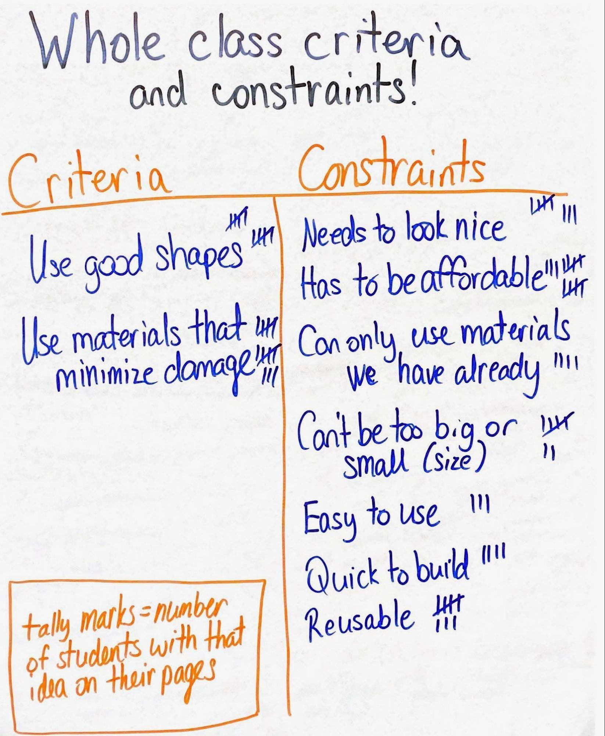
If multiple students feel an idea is important, place a star next to the idea or place tallies next to the idea to represent the number of students with that idea.

Discuss commonalities in charts. Instruct students to look at the Building a Better Phone Case chart and compare it to the Whole-class Criteria and Constraints chart that was just created. Ask students to share the similarities and differences of the charts. The criteria and purpose should be the same, and the constraints will have expanded sections on the new chart. Reiterate to students that the criteria are based upon the overall goals or purpose of the design, so it makes sense that the criteria are the same for all the different devices since they are serving the same purpose for a variety of objects.

Say, We have a great list of criteria and constraints that we all agree would be helpful in designing our devices. But, this has me thinking about a lot of questions related to how we will design the best device we can to limit damage. What new questions does this raise for you about the materials, design, structure, and function of these devices? Let’s write our questions down with possible ways to investigate them.

8 · DEVELOP QUESTIONS AND IDEAS FOR INVESTIGATIONS | 20 min
MATERIALS: 3 more 3”x3” sticky notes, Protection Device Design Thinking, Drafting Our Protection Device Design, partner feedback sticky notes, Objects that need (better) protection during a collision chart, Building a Better Phone Case chart, Whole-class Criteria and Constraints chart, chart paper, markers
Document questions and ideas for investigation. Project slide N. Arrange students in a Scientists Circle around a piece of chart paper. Pass out sticky notes to students. Ask students to look back at the class-created charts, their handouts, others’ designs, and any feedback they received from others. Have students consider what questions they now have about the materials, design, structure, and function of the protection devices. Students will record on sticky notes at least 2 questions about materials, design, structure or function and record on at least 1 sticky note an idea for investigation. While students are recording their questions and ideas for investigation, set up a new T-chart on chart paper with the left side titled “What we need to figure out” and the right side “How we can investigate this.”

Share questions and ideas for investigation. Project slide O. Review with students the expectations for sharing questions and ideas for investigation.
- One by one, we will go around and share one question and one idea for investigation.
- As the first person reads a question and an idea for investigation, give a thumbs up if you wrote down the same question or the same idea for investigation.
- The person reading the question and the idea will collect the sticky notes with the same question and the same idea for investigation from people with their thumbs up and will layer them on top of each other.
- The reader will then post them on our T-chart in the appropriate column.
- After this, the next person in the circle will read a question and an idea for investigation until all relevant questions and ideas are on the board.

Go around the circle and let students each read one question and one idea for investigation. Continue this until all questions and ideas are presented on the T-chart.

9 · NAVIGATION | 4 min
MATERIALS: None
Motivate the need for material testing. Say, We have a lot of questions and ideas for investigations, and a lot of them seem to deal with our shared list of criteria and constraints.

Project slide P. Ask students to turn and talk about the following question:
- If we are going to design a protection device, what is something that we all need to investigate to help us build a better device?

Elicit student responses. Use the prompts and responses below to guide navigation to the next lesson. It is OK if this discussion is continued at the beginning of Lesson 12 if time is short.

Suggested prompt | Sample student response
If we are going to design a protection device, what is something that we all need to investigate to build a better device? | Maybe look at criteria and constraints.
So maybe we need to start with criteria to figure out how to protect our objects. What actually does the protecting of the object? What criteria do we need to figure out more about first? | Maybe the materials?
But how will we know what the best materials are to use? What would make one material better than another? | The materials would have to protect better than another material. It would do a better job protecting the object.
OK. But if we test the different materials, how will we know that one material is better at preventing or reducing the damage done on something it is protecting in a collision? | We’d have to see which one produced less peak force on an object we’re trying to protect.
How could (or why would) measuring peak forces produced by different materials in a collision help us figure out which ones are more effective at preventing or reducing damage in a collision? | The materials that produce less peak force in a collision should be more effective at preventing or reducing damage in a collision.

Say, As you leave class, start thinking about what we’ve done in the past and the equipment that we’ve used that we can repurpose to test different materials in a collision to see how they affect the peak forces in a collision. Getting some results for that next time will help us make informed decisions about one important criteria for determining which material types would work better for our designs.

If desired, collect Drafting Our Protection Device Design as a pre-assessment of ideas developed in Lessons 12-15. Make copies of the handout and use the copies to compare to the student's individual models at the end of this lesson set. Return Drafting Our Protection Device Design to students at the beginning of Lesson 12.

